# **CAPSTONE**

**Computer Vision for Real-Time Monkeypox Diagnosis on Embedded Systems**

# **Introduction**

The COVID-19 pandemic not only highlighted the global disparities in healthcare access, particularly in developing countries with limited resources and infrastructure, but also highlighted the critical importance of accurate and timely diagnostic tools in managing infectious disease outbreaks [[1]](https://www.zotero.org/google-docs/?nzyPTM). With over 7 million deaths and countless cases worldwide [[2]](https://www.zotero.org/google-docs/?2tA6bE), this crisis underscored the urgent need for robust public health systems and innovative diagnostic tools [[3]](https://www.zotero.org/google-docs/?VqkF0F). Similarly, the recent outbreaks of monkeypox (Mpox), including the 2022 outbreak [[4]](https://www.zotero.org/google-docs/?KSHZUa) and the new strain in 2024 which has already resulted in over 15,600 cases and 537 deaths [[5]](https://www.zotero.org/google-docs/?etEPAo), have further exposed vulnerabilities in our ability to quickly diagnose and contain emerging infectious diseases. The symptoms of Mpox, such as fever, headache, muscle pain, and blistering rashes [[6]](https://www.zotero.org/google-docs/?fjJBRE), are often challenging to diagnose accurately, particularly in resource-limited settings where advanced diagnostic tools are not readily available. Artificial Intelligence (AI) systems provide an approach to tackle this issue as they have become a staple with their applications in infectious disease detection and diagnosis.

Traditional diagnostic methods, such as the Polymerase Chain Reaction (PCR) test, have shown limitations in accurately diagnosing Mpox due to the short window of virus presence in the bloodstream and variability in infection stages [[7]](https://www.zotero.org/google-docs/?HK9oRB). Moreover, the PCR test can take a few days of processing to produce results, and their availability in rural or remote areas is greatly hindered. This has led to a pressing need for novel diagnostic approaches that can provide accurate and timely results, especially in areas with limited access to healthcare infrastructure. Our project aims to address this gap by leveraging the capabilities of artificial intelligence (AI) and computer vision to develop a reliable, fast, and deployable diagnostic tool for Mpox.

AI, particularly machine learning (ML) and computer vision has shown great potential in revolutionizing healthcare diagnostics by enabling the analysis of complex medical data with high accuracy and speed [[8]](https://www.zotero.org/google-docs/?EhC2jq). In the context of Mpox, AI-driven models can be particularly valuable in resource-limited environments, where access to expert medical professionals and advanced diagnostic tools is scarce. By utilizing models and deploying them on embedded systems, we can create a diagnostic tool that is not only accurate but also efficient and accessible, addressing the critical need for rapid and reliable Mpox diagnosis in vulnerable populations.

We propose developing an automated diagnostic tool using advanced computer vision techniques to meet the urgent need for accurate and rapid Mpox diagnostics. Our approach will leverage a model with a pre-trained deep-learning architecture known for its efficiency and lightweight structure [[9]](https://www.zotero.org/google-docs/?Dp2KiI). Then, we would apply transfer learning with a monkeypox skin lesion dataset to fine-tune the model specifically for Mpox detection. By integrating NVIDIA's TensorRT framework, we will optimize this model for deployment on the NVIDIA Jetson Orin, a compact yet powerful embedded system. This novel solution is designed to be both efficient and scalable, making it ideal for use in resource-constrained environments where timely and accurate diagnosis can significantly improve public health outcomes.

# **Problem Statement**

Access to fast and reliable diagnostic tools for infectious diseases is critically limited, particularly in rural and underserved areas where basic healthcare infrastructure is often insufficient. This gap in healthcare access hampers the ability to predict, diagnose, and contain infectious diseases, increasing the risk of localized outbreaks escalating into global pandemics. A pressing example is the emergence of the new Mpox variant, which is currently causing significant public health challenges in Africa and spreading to parts of Europe and Asia [[10]](https://www.zotero.org/google-docs/?fcwnvd). The limitations of the current PCR test, including varying accuracy based on the disease's life cycle and prolonged wait times for results, highlight the urgent need for innovative diagnostic methods that can overcome these constraints. Failure to address this need could result in delayed diagnoses, ineffective containment efforts, and worsened health outcomes on a global scale.

Our project targets the healthcare domain, with a specific focus on professionals operating in resource-limited settings such as rural clinics, mobile health units, and temporary healthcare facilities in outbreak zones. These healthcare providers often face significant challenges in diagnosing infectious diseases due to the lack of advanced diagnostic tools and limited access to specialist support. By equipping these professionals with a user-friendly, real-time diagnostic tool, we aim to empower them to make accurate and timely decisions, ultimately improving patient outcomes and reducing the spread of Mpox in vulnerable communities.

To address the limitations of current diagnostic methods, we propose leveraging artificial intelligence (AI) and computer vision technologies to develop a real-time diagnostic tool specifically designed for Mpox infection. This innovative approach involves using a computer vision model to analyze images of skin lesions, a common symptom of Mpox, to assess the likelihood of infection. Unlike traditional methods [[11]](https://www.zotero.org/google-docs/?1qqqas), our solution will employ a lightweight, efficient model that can be deployed on embedded systems, making it suitable for use in resource-constrained environments. This innovation is poised to significantly enhance the accessibility and accuracy of Mpox diagnosis, providing a critical tool for healthcare professionals in underserved areas where rapid and reliable diagnosis is most needed.

Our project aims to make a meaningful contribution to the healthcare domain by providing a cost-effective, efficient diagnostic solution that can be deployed in the most challenging environments. By focusing on Mpox, a disease with growing global relevance, we seek to enhance the accessibility of accurate diagnosis in underserved areas, thereby improving public health outcomes through early detection and timely treatment. Additionally, this project will advance the application of AI in healthcare, demonstrating the potential of computer vision models to transform the way infectious diseases are diagnosed, particularly in settings with limited resources.

# **Project Objectives**

**Project General Goal**

This project aims to develop an AI-powered diagnostic tool that accurately identifies monkeypox (Mpox) from skin lesion images. This tool will be deployable in resource-constrained environments, providing healthcare professionals with a reliable, real-time solution to improve disease detection and containment efforts.

#### **Objective 1: Identify a Relevant Dataset**

* **Specific**: Identify a Mpox skin lesion dataset suitable for training the computer vision model.
* **Measurable**: The dataset should be open-source and have a usability score of at least 7.0 on Kaggle.
* **Achievable**: Review and compare available datasets and relevant literature to ensure the selected dataset meets the usability requirements.
* **Relevant**: Selecting a high-quality dataset is crucial for effectively training the model and minimizing the risk of overfitting or underfitting.
* **Time-based**: This objective should be completed by September 6.

#### **Objective 2: Identify a Lightweight Pre-Trained Model**

* **Specific**: Identify an efficient pre-trained model that can be adapted for deployment on embedded systems.
* **Measurable**: The selected model should be capable of achieving a baseline accuracy of at least 85% on initial tests.
* **Achievable**: Utilize an existing state-of-the-art model, such as MobileNet or EfficientNet, as the foundation for this project.
* **Relevant**: Choosing the right model is crucial as it will significantly influence the final accuracy, efficiency, and deployment feasibility, thus reducing development time.
* **Time-based**: This objective should be completed by September 6.

#### **Objective 3: Model Development and Accuracy**

* **Specific**: Develop a computer vision model using a pre-trained architecture, fine-tuned with a Monkeypox Skin Lesion Dataset.
* **Measurable**: Achieve a model accuracy of at least 90% in correctly identifying Mpox from skin lesion images during tests.
* **Achievable**: Leverage data augmentation and transfer learning techniques to enhance model performance, ensuring it meets the accuracy requirement.
* **Relevant**: The accuracy of the model is crucial for the tool’s effectiveness in real-world scenarios, particularly in resource-limited settings where misdiagnosis can have serious consequences.
* **Time-based**: Complete model development and achieve the accuracy benchmark by September 15.

#### **Objective 4: Model Optimization for Deployment**

* **Specific**: Optimize the trained model using NVIDIA's TensorRT framework to ensure it is lightweight and capable of real-time processing on the NVIDIA Jetson Orin platform.
* **Measurable**: Reduce the model's average inference time to under 500 milliseconds while maintaining the accuracy threshold.
* **Achievable**: Utilize TensorRT's model compression techniques and hardware-specific optimizations to meet performance goals.
* **Relevant**: Ensuring the model is optimized for real-time deployment is critical for its use in environments where computational resources are limited.
* **Time-based**: Achieve this optimization and deploy the model on the Jetson Orin by October 30.

#### **Objective 5: Web Application**

* **Specific**: Create a web-based user interface (UI) to display the results of the AI inference generated by the Jetson Orin.
* **Measurable**: The application should display inference results (e.g., Mpox diagnosis probability) within 5 seconds of receiving data from the Jetson Orin.
* **Achievable**: Utilize common web frameworks like Flask or Django for backend integration, and HTML/CSS/JavaScript for the frontend, ensuring compatibility with the Jetson Orin’s system architecture.
* **Relevant**: This web application will serve as the primary interface between the AI model and the end-user, providing a clear and accessible way to view diagnostic results.
* **Time-based**: Achieve the web application by November 15.

#### **Objective 6: Wifi Access Point (AP) Hotspot**

* **Specific**: Set up the Jetson Orin as a WiFi AP to allow devices to upload skin lesion images directly to the model for analysis.
* **Measurable**: The system should successfully transfer skin lesion images from a device to the Jetson Orin within 5 seconds.
* **Achievable**: Use the built-in WiFi capabilities of the Jetson Orin and configure the device as an AP, ensuring seamless image transfer between a device and the embedded system.
* **Relevant**: Establishing a WiFi AP hotspot allows the system to function in remote areas without needing external network infrastructure, thus improving the deployability of the solution in resource-constrained settings.
* **Time-based**: Interface web application with Jetson Orin and run final tests by December 6.

# **Solution Approach**

We propose an AI-powered automatic diagnosis tool for detecting monkeypox (Mpox) through image analysis. This solution leverages a machine learning model, specifically utilizing computer vision techniques to classify images of skin lesions. By compressing the model and deploying it on an embedded system, such as the Jetson Orin, the diagnostic tool can perform real-time analysis of images captured via a phone camera or regular camera connected to the embedded system. This setup enables rapid, on-device diagnosis without the need for high computational resources or access to centralized labs. The solution is ideal for resource-constrained environments, such as low-income or rural communities, making it a highly accessible option for global healthcare systems.

For the model, we’re considering using either MobileNet or EfficientNet. They’re both models trained by Google, small in scale compared to other models, and have high accuracy. EfficientDet has good detection and accuracy capabilities, whereas MobileNet is more focused on accuracy [[12]](https://www.zotero.org/google-docs/?GsIAHE). The team is leaning towards MobileNet since, as the name suggests, it is made to be deployed on mobile devices. This will make it easier to compress and deploy in an embedded system.

We are inclined to use the **Jetson Orin** as the embedded system to deploy the machine learning model. One of the primary reasons for considering this platform is its integrated GPU, which allows us to leverage **TensorRT** for model compression, optimizing performance without requiring significant computational resources. The Jetson Orin is also well-suited for AI applications, making it an ideal choice for real-time image processing. However, there are risks associated with this approach, notably the possibility that the model may not perform as expected after compression. Despite utilizing TensorRT for optimization, there remains the chance that the compressed model's accuracy or performance might degrade to a point where it is no longer viable for reliable diagnosis.

To demonstrate the solution, we are exploring multiple options for how the system will interact with users. One approach is to develop a **server-based web application** that establishes a connection between the model and the user. In this scenario, a user, potentially accessing the system via a smartphone with a camera, would upload an image of a skin lesion. This image would be sent to the server, processed by the AI model, and the diagnosis result would be displayed on the web application. This solution provides flexibility and scalability, as it allows remote access to the diagnostic tool.

Alternatively, we are considering directly connecting the Jetson Orin Nano with **Wifi AP Hotspot** to create a more localized, real-time solution. Another possibility is to use Bluetooth. While Bluetooth communication does exist and has been tested for file transfer, we are still uncertain whether it can reliably support the volume and speed of data transfer needed for image diagnosis in this context. Given these uncertainties, a **direct connection to a compatible camera** might be the simplest and most straightforward approach for initial testing and demonstration, as it eliminates the potential complications of wireless communication.

We are also evaluating other hardware options, such as the **Arduino Nano**, but are not entirely sure of its efficacy due to its lack of a GPU. The Jetson Orin has a more established track record for handling machine learning tasks, particularly those requiring computer vision, making it a possible better fit for our use case.

Currently, the gold standard for monkeypox detection is the Polymerase Chain Reaction (PCR) test. However, the PCR method has significant drawbacks:

* **High cost per PCR test**: Each test can cost approximately $175 [[13]](https://www.zotero.org/google-docs/?9BNJ00), making it expensive, especially in low-resource settings where healthcare budgets are constrained.
* **Long wait times for results**: PCR test results take anywhere from 3 to 7 days, which can delay patient care, treatment, and isolation decisions [[14]](https://www.zotero.org/google-docs/?WQF3HV).
* **High false positive rates**: PCR tests often suffer from high false positives due to human error and the lack of universal standards on how to conduct the tests [[14]](https://www.zotero.org/google-docs/?nwpiF6). The variability in testing procedures across laboratories contributes to inconsistencies and inaccuracies.

Our solution addresses these shortcomings by offering a faster, more cost-effective method for diagnosing monkeypox with the potential to reduce human error through automated image-based analysis. The key value propositions of our solution are as follows:

* **Accessibility**: By compressing the model to run on an embedded system, this tool becomes accessible in resource-constrained environments, expanding its reach to areas with limited access to advanced healthcare facilities.
* **Reduced wait time**: Our AI-powered tool offers a significant reduction in the time required for diagnosis, providing results in real-time, as opposed to the 3-7 day wait time for PCR results. It could improve treatment outcomes and reduce the risk of spread in outbreaks.
* **Cost-efficiency**: The cost per test using this technology would be significantly lower than the PCR tests, making it an affordable solution for both healthcare providers and patients.
* **Embedded system integration**: The ability to communicate with a smartphone via Wifi AP hotspot or similar connectivity allows seamless integration with existing technology platforms, making it user-friendly for healthcare professionals.

These factors together make the proposed solution a more efficient, scalable, and cost-effective alternative to existing methods. However, it isn’t without its limitations and risks.

* **Model performance after compression**: Compressing the model for deployment on the embedded system may lead to reduced efficiency, resulting in a potential decrease in the accuracy of diagnosis.
* **Risk of incorrect diagnosis**: Although the solution will be subjected to rigorous standards to meet certain diagnosis accuracy, it is almost certain that the accuracy will not be perfect, which can lead to harmful false negatives.
* **Regulatory hurdles**: Achieving regulatory approval (such as from the FDA or other global health authorities) may be a challenging process. Compliance with medical standards for AI-driven diagnostics will be critical for market entry.

Monkeypox has seen a resurgence in recent years, with notable outbreaks, including one confirmed in the UK in May 2022 [[15]](https://www.zotero.org/google-docs/?Bxw1jL). This has highlighted the urgent need for reliable, rapid diagnostic tools. The growing demand for improved diagnostic solutions in healthcare provides a strong commercial opportunity for our AI-powered tool. As of December 2023, the PCR test remains the only available diagnostic tool for identifying monkeypox. However, its drawbacks, including high costs and long wait times, create a market gap that our solution can fill. By offering a faster, more affordable alternative, we can help healthcare providers diagnose and treat monkeypox more efficiently.

Our project has the potential to generate several intellectual property assets, including the model compression pipeline for deploying AI models on embedded systems and the web application interface designed for real-time monkeypox diagnosis. To manage intellectual property concerns, we will adhere to the University of Puerto Rico's intellectual property policies [16]. This will ensure that any IP generated during the project is appropriately documented and ownership rights are clearly defined. Additionally, in order to protect and potentially commercialize our work in the future, we will explore options for filing patents or other IP protections for project components that demonstrate significant innovation.

# **Technical Description**

The architecture of the system will start by taking an image of the skin as input to the model. This image will be given by the user from the web application and be able to choose which image the user wants to verify if it has monkeypox or not. Then the model will determine if the image has Mpox by going through the compressed model in the embedded system that we choose. This will return the user if the image was found to be Mpox by the model. This architecture can be observed in Figure 1.

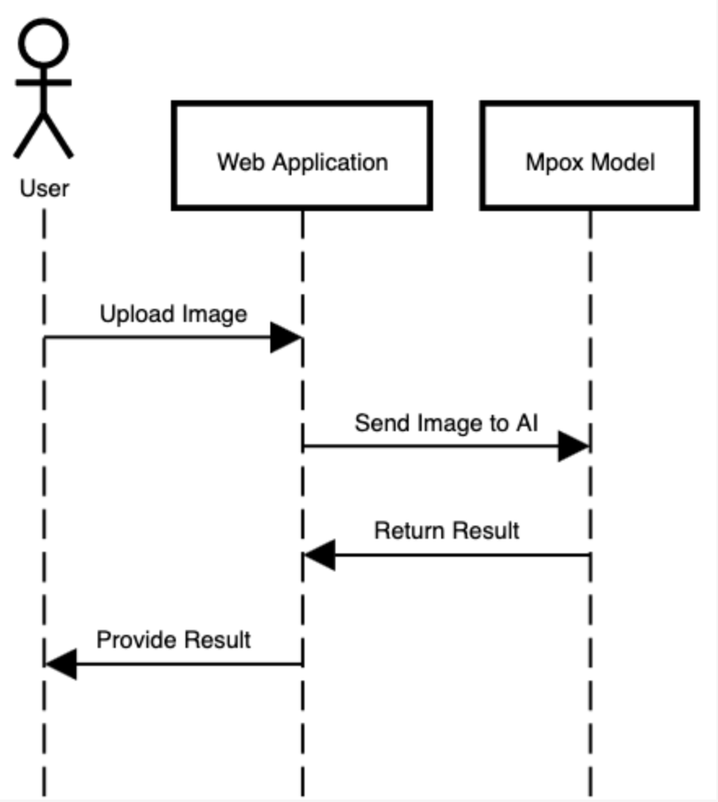

**Figure 1: System Architecture**

Multiple steps need to be completed to create this interface as described in Figure 2.

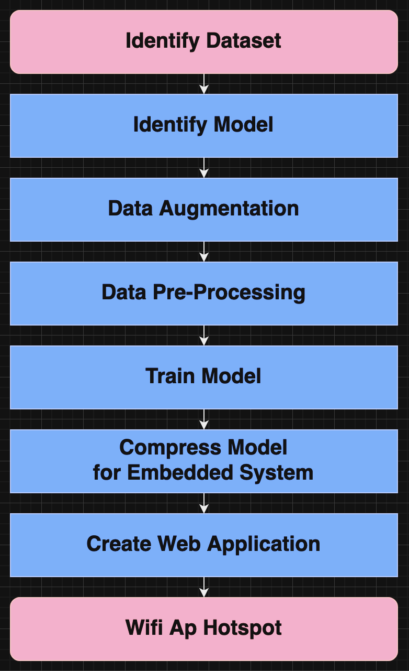

**Figure 2: Modules to Implement**

The first two steps involve selecting an appropriate dataset and identifying a pre-trained model for transfer learning. The dataset will be sourced from platforms like Kaggle or other reliable sources with high usability ratings. Once the dataset is chosen, we will proceed with selecting a pre-trained model suitable for transfer learning. Data augmentation techniques will then be applied to enhance the dataset. This is a critical step to ensure that the model can generalize well to different scenarios.

Data augmentation will involve manipulating the original dataset by applying various transformations, such as flips, rotations, zooms, and contrast adjustments, as presented in Figure 3. This process increases the dataset’s size and variability, allowing the model to better recognize images in various orientations and lighting conditions. These techniques help the model improve its ability to correctly classify images under different circumstances, thereby reducing the risk of overfitting.

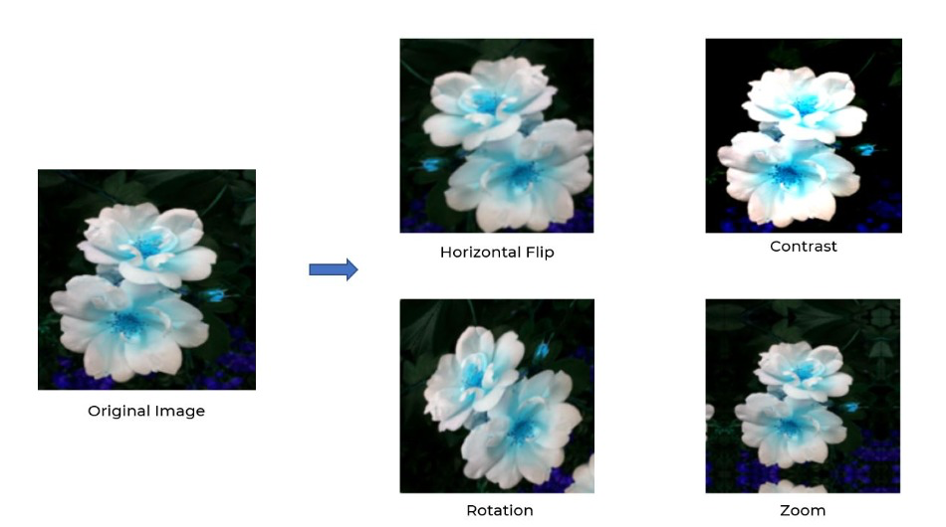

**Figure 3: Data Augmentation Example**

Before training, the data will undergo preprocessing, including scaling and normalization, to ensure consistency with the model’s input format. This preprocessing will be performed using Keras and TensorFlow libraries. Properly preprocessed data is essential for the model’s accuracy and performance. Then, transfer learning will be employed to fine-tune a pre-trained model using the selected dataset. This involves removing the final layer of the pre-trained model and retraining it with our dataset, allowing the model to adapt to monkeypox detection as described in Figures 4 and 5. This process will also be done using Keras and TensorFlow libraries. Transfer learning is an efficient way to train a model, leveraging existing knowledge to reduce the amount of training data and time required.

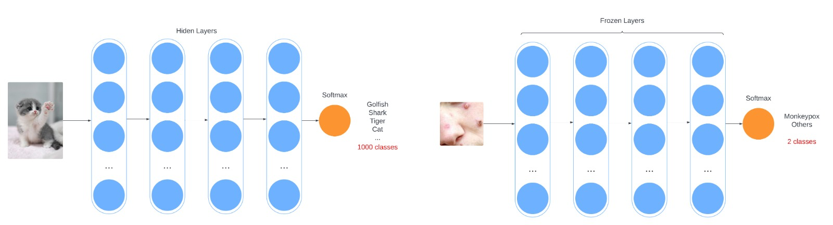

**Figure 4: Original Model**



**Figure 5: Transfer Learning**

Once trained, the model will be compressed using NVIDIA’s TensorRT framework to optimize it for real-time inference on embedded systems like the Jetson Orin. This compression is necessary to ensure the model can run efficiently on limited hardware. While TensorRT is well-integrated with the Jetson Orin, a potential constraint is that some models may not compress well due to their size, or compatibility issues may arise with other embedded systems. However, Jetson Orin is preferred due to its native support for TensorRT, making it an ideal choice for this project. Other alternatives like Arduino Nano were considered but may pose compatibility challenges.

After the model is deployed, a web application will be created to serve as the user interface. This interface will allow users to upload skin lesion images and receive predictions from the AI model. The web application will be developed using HTML, CSS, and JavaScript to ensure simplicity and responsiveness. The interface will display the model’s prediction in a clear, user-friendly format. Wireframes similar to Figure 6 will be designed to outline the layout of the web application, ensuring that the user experience is intuitive.

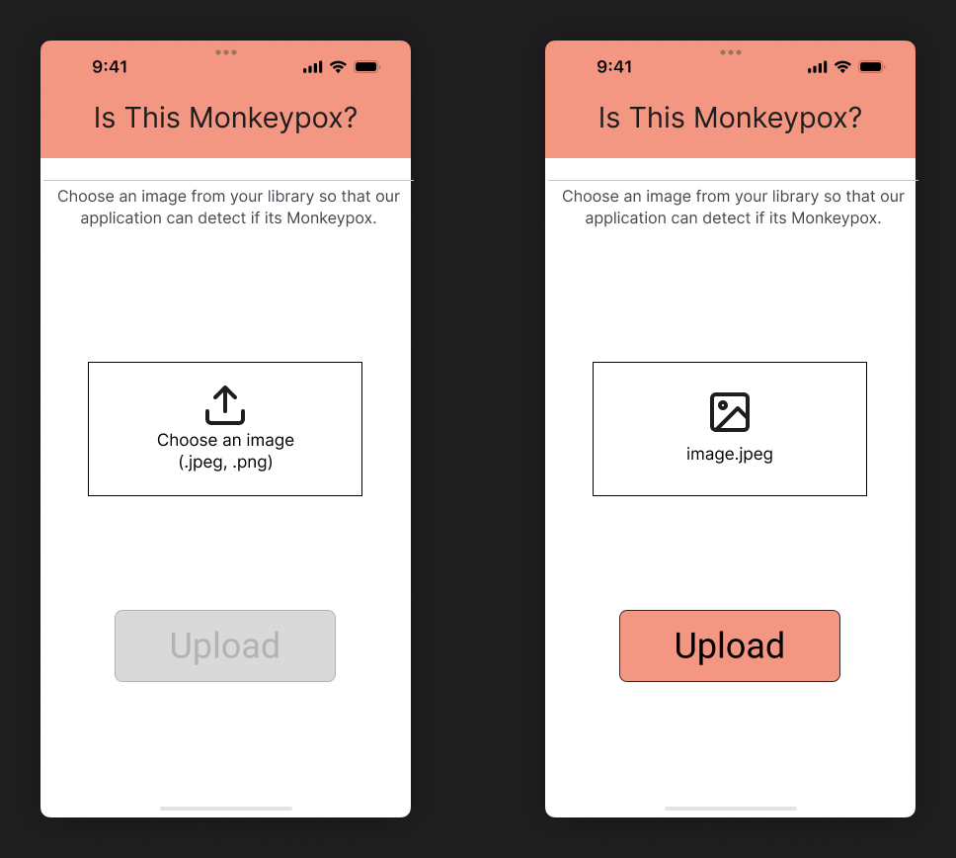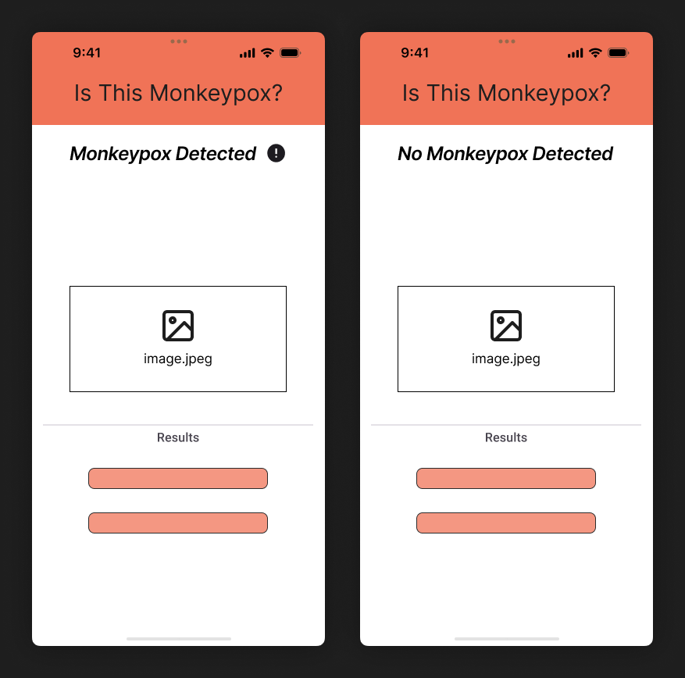

**Figure 6: Wireframes for Web Application Layout**

To facilitate image input, the Jetson Orin will be configured as a WiFi access point (AP) [[17]](https://www.zotero.org/google-docs/?UJDW6F), allowing mobile devices to connect and upload images directly. This approach enables real-time interaction between the mobile device and the AI model without requiring external network infrastructure. Alternative methods such as Bluetooth or an integrated camera in the embedded system were considered but were deemed less reliable due to potential connectivity issues. The success of the WiFi AP configuration will be tested to ensure it works seamlessly with the Jetson Orin.

Lastly, to ensure the project adheres to high-quality standards, we will follow several established engineering standards. Usability will be assessed based on **ISO 9241-11:2018**, which measures how well the solution meets real-world user needs. Development will follow the agile methodology in accordance with **ISO/IEC/IEEE 12207:2017**, ensuring iterative and flexible project management. For the web application, we will apply the **ISO 9241-210:2019** standard to guarantee simplicity, usability, and user-friendliness.

# **Project Plan**

Our team will be working together throughout the project; therefore, our roles are best described as FullStack. Everyone will be part of every section of the project. However, there are sections of the project where a member will have primary responsibility:

**Jacob M Delgado:** Will be responsible for the identification of the model, as well as the augmentation of the dataset and training the model.

**Sebastian O Espinosa:** Will work on the compressing of the model and deployment into the embedded system, making sure it satisfies the predefined requirements after compressing.

**Ricardo A Morell:** Will mostly focus on the interface aspect, identifying the best option for our use case and helping the team with the implementation of it.

The following Work Breakdown Structure (WBS) in Figure 7 shows what our milestones are, and the tasks that must be completed for each milestone for the project to be considered completed.

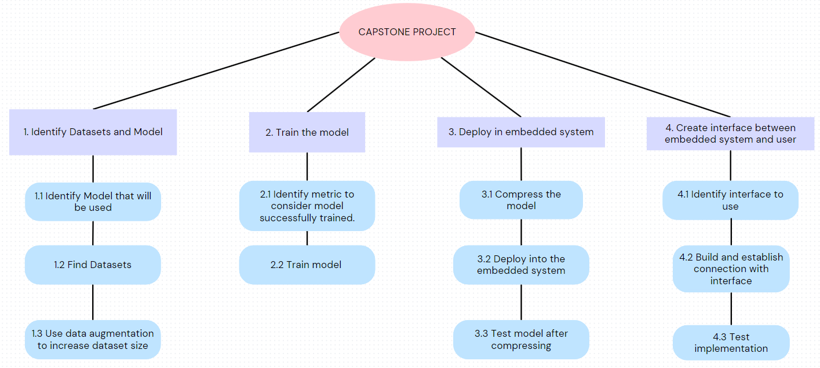

**Figure 7: Work Breakdown Structure (WBS)**

The second level, or purple level, outlines the milestones of the project. The third level, or the blue level, outlines the tasks that must be completed to consider the respective milestone as done. Important to note that the tasks are placed in order of getting completed since most of them are sequential.

The first milestone is about identifying the dataset and model that we will be using. As stated previously, we are considering using either MobileNet or EfficientDet. Once we choose the model, it’ll be easier to find a dataset more tailored to the model. For the dataset, we plan on searching through Kaggle and identifying one with at least a 7.0 rating. Once we have the dataset, we’ll use data augmentation to increase the size. Data augmentation is the practice of doing operations on the images in the dataset, such as adding zooms, rotations, blurs, etc. The main reason is that when we train the model, it isn’t too sensitive when identifying Monkeypox and it’s more broad when analyzing the image. We expect this to be done by **September 6, 2024.**

The second milestone is about training the model chosen. The team will be using Transfer Learning, which would take the pretrained model that we choose and train it to identify Monkeypox by image analysis. We would choose a metric to establish when the model will be considered trained. Ideally, we would choose among the known ML Metrics such as Recall, Accuracy, Precision and F1 Score. The decision on which metric to choose will depend on what our target demographic would value more to consider our solution viable. We expect to have the model fully trained by **September 15, 2024**.

The third milestone is focused on compressing the trained model to an embedded system. We expect a decrease in key metrics such as accuracy or precision after compression. Therefore, our main goal in this milestone is to successfully compress the model while losing the least amount possible of key metrics and still be a viable solution for Monkeypox detection. We expect to finish this milestone around **October 30, 2024**.

For the final milestone, we plan on building an interface between the embedded system model and the potential user. As stated previously, we are considering the creation of a web server application, a Wifi AP Hotspot connection between a phone and the system, or a simple camera connected to the embedded system. After deciding what implementation we’ll be doing, the team will begin to develop it. We expect that the interface should be able to capture an image and correctly identify if it’s Monkeypox or not. The milestone should be completed by **December 6, 2024**.

# **References**

[[1] A. T. Levin *et al.*, “Assessing the burden of COVID-19 in developing countries: systematic review, meta-analysis and public policy implications,” *BMJ Glob Health*, vol. 7, no. 5, p. e008477, May 2022, doi: 10.1136/bmjgh-2022-008477.](https://www.zotero.org/google-docs/?tyaU4J)

[[2] “COVID-19 deaths reported (2024 global),” datadot. Accessed: Aug. 25, 2024. [Online]. Available: http://data.who.int/dashboards/covid19/circulation](https://www.zotero.org/google-docs/?tyaU4J)

[[3] “Coronavirus disease (COVID-19) pandemic.” Accessed: Aug. 25, 2024. [Online]. Available: https://www.who.int/europe/emergencies/situations/covid-19](https://www.zotero.org/google-docs/?tyaU4J)

[[4] M. Hraib, S. Jouni, M. M. Albitar, S. Alaidi, and Z. Alshehabi, “The outbreak of monkeypox 2022: An overview,” *Ann Med Surg (Lond)*, vol. 79, p. 104069, Jun. 2022, doi: 10.1016/j.amsu.2022.104069.](https://www.zotero.org/google-docs/?tyaU4J)

[[5] “WHO Director-General declares mpox outbreak a public health emergency of international concern.” Accessed: Aug. 25, 2024. [Online]. Available: https://www.who.int/news/item/14-08-2024-who-director-general-declares-mpox-outbreak-a-public-health-emergency-of-international-concern](https://www.zotero.org/google-docs/?tyaU4J)

[[6] “Mpox (monkeypox).” Accessed: Aug. 25, 2024. [Online]. Available: https://www.who.int/news-room/fact-sheets/detail/monkeypox](https://www.zotero.org/google-docs/?tyaU4J)

[[7] A. Paniz-Mondolfi *et al.*, “Evaluation and validation of an RT-PCR assay for specific detection of monkeypox virus (MPXV),” *J Med Virol*, vol. 95, no. 1, p. e28247, Jan. 2023, doi: 10.1002/jmv.28247.](https://www.zotero.org/google-docs/?tyaU4J)

[[8] H. Habehh and S. Gohel, “Machine Learning in Healthcare,” *Curr Genomics*, vol. 22, no. 4, pp. 291–300, Dec. 2021, doi: 10.2174/1389202922666210705124359.](https://www.zotero.org/google-docs/?tyaU4J)

[[9] A. G. Howard *et al.*, “MobileNets: Efficient Convolutional Neural Networks for Mobile Vision Applications,” Apr. 16, 2017, *arXiv*: arXiv:1704.04861. doi: 10.48550/arXiv.1704.04861.](https://www.zotero.org/google-docs/?tyaU4J)

[[10] “Mpox is still being transmitted across the world, says UN health agency | UN News.” Accessed: Aug. 26, 2024. [Online]. Available: https://news.un.org/en/story/2024/08/1153141](https://www.zotero.org/google-docs/?tyaU4J)

[[11] H. Lindroth *et al.*, “Applied Artificial Intelligence in Healthcare: A Review of Computer Vision Technology Application in Hospital Settings,” *J Imaging*, vol. 10, no. 4, p. 81, Mar. 2024, doi: 10.3390/jimaging10040081.](https://www.zotero.org/google-docs/?tyaU4J)

[[12] E. Kim, “Difference between SSD Mobi, EfficientNet and Faster R-CNN ResNet 50,” Medium. Accessed: Sep. 05, 2024. [Online]. Available: https://medium.com/@elvenkim1/difference-between-ssd-mobi-efficientnet-and-faster-r-cnn-resnet-50-928f6600a1fa](https://www.zotero.org/google-docs/?tyaU4J)

[[13] “Mpox (Monkeypox) virus PCR,” Canterbury Health Laboratories. Accessed: Sep. 03, 2024. [Online]. Available: https://www.chl.co.nz/test/monkeypox-virus-pcr/](https://www.zotero.org/google-docs/?tyaU4J)

[[14] J. F. Huggett, D. French, D. M. O’Sullivan, J. Moran-Gilad, and A. Zumla, “Monkeypox: another test for PCR,” *Euro Surveill*, vol. 27, no. 32, p. 2200497, Aug. 2022, doi: 10.2807/1560-7917.ES.2022.27.32.2200497.](https://www.zotero.org/google-docs/?tyaU4J)

[[15] M. Hraib, S. Jouni, M. M. Albitar, S. Alaidi, and Z. Alshehabi, “The outbreak of monkeypox 2022: An overview,” *Ann Med Surg (Lond)*, vol. 79, p. 104069, Jun. 2022, doi: 10.1016/j.amsu.2022.104069.](https://www.zotero.org/google-docs/?tyaU4J)

[[16] upr_admin, “Propiedad intelectual,” Universidad de Puerto Rico. Accessed: Sep. 15, 2024. [Online]. Available: https://www.upr.edu/investigaciones/propiedad-intelectual/](https://www.zotero.org/google-docs/?tyaU4J)

[[17] “Creating Wifi AP Hotspot on Jetson Nano - Jetson & Embedded Systems / Jetson Nano,” NVIDIA Developer Forums. Accessed: Sep. 10, 2024. [Online]. Available: https://forums.developer.nvidia.com/t/creating-wifi-ap-hotspot-on-jetson-nano/72982/2](https://www.zotero.org/google-docs/?tyaU4J)